WEST LONDON WASTE AUTHORITY
Report of the Projects Director | 20th January 2023
Communications Programme Update
SUMMARY
This report provides an update on the WLWA Communications Programme.
- More than 60% of residual waste has existing diversion capture systems adding unnecessary cost into Borough systems, wasting resources that are permanently lost to the system. Capturing that lost material will give us the opportunity to reduce carbon impact, reduce cost, increase recycling and create the basis for a strong circular economy.
- Budgeted external support will bring in expertise and inform changes that will assist us to move from the current steady state reasonable levels of recycling to a new knowledge base which will empower members of the public to reach new levels of recycling.
- Resident insights will demonstrate how our current systems are perceived and offer opportunities to refine our message and potentially services to ensure systems are used to their maximum and materials are returned for recycling and reuse.
- Working together will enable us to create consistency of message and to optimise our resources to maximum benefit.

RECOMMENDATION(S)

- The Authority is asked to note the information within this report.

- Introduction
The communications programme in the budget for three years from 2023 is designed to measure the levels of knowledge, engagement and participation of residents across the region. This will be used to create new and direct messaging to help shift residents’ approach to waste reduction, material diversion and recycling resulting in more efficient usage of the service already provided.
Food waste recycling is the service that most citizens don’t use (Appendix 1). Persuading every household to recycle food waste will reduce waste, reduce cost, increase recycling and contribute to global and UK decarbonisation. It will result in cost savings for citizens, Boroughs and WLWA. Cost savings for WLWA and Boroughs means more money available to invest in other recycling services. We want to normalise food waste recycling and ban food waste from the bin.
Plastics recycling is extremely complex, some plastics are technically and economically easy to recycle, some are very difficult. Most plastics are made from fossil oil which is environmentally damaging. The producers of plastic packaging want to make more and have us recycle more plastic, the public attitude appears to be for less plastic.
Textile recycling is low volume but high value of both cost and carbon. Textiles are rapidly becoming as complex as plastics with 100s of grades of different material, from eg. cotton, wool, mixed fibres to types of plastic. We want to prevent textiles from going in the bin.
Electricals and batteries - Large electrical items are predominantly recycled if taken back in store or to HWRCs but a) small electrical items find their way into the bins and b) we need to preserve the value of the product through reuse. Electricals and batteries in the bin cause fires and are environmentally damaging.
The output will be baseline citizen knowledge, understanding of complex recycling systems and the links with climate change. Create and deliver content designed to significantly increase citizen knowledge and attitudes. Baseline again and review the waste and recycling statistics and outcome of the social value and reuse project.
- Waste Composition Analysis
The 2022 waste composition analysis has been completed by Integrated Skills Ltd (ISL). To ensure consistency of methodology ISL also revisited the data from WCA in 2020 and 2021 so that we have a consistent dataset. WLWA Average composition detailed in Appendix 1.
Food waste - as reported in the last meeting food waste remains the highest proportion of the residual waste at c.34%. This volume represents c.75% of the total food waste generated in the region with the remaining 25% captured in the food waste service.
Dry Mixed Recycling (DMR) – the DMR in the residual waste accounts for a further 17% of the total volume with similar volumes of glass (4%), plastic (4%), paper (3%) and card (4%).
Garden Waste – all Boroughs provide garden waste services however 6% of the residual waste is garden waste.
Textiles – textiles have the highest embedded carbon of all the materials disposed of in the residual. This high carbon content combined with the volume (4%) puts textiles as a priority target for intervention. Free household textile collections are available across the Boroughs through our partnership with TRAID.
Waste Electricals – There the composition analysis shows the continuing trend for waste electricals (1%) to be disposed of in the residual waste. This poses a risk to Borough and WLWA operations through fires caused by batteries and capacitors in waste electricals. The TRAID textiles service available across the Boroughs is trailing the collection of separately presented waste electricals with a bag of textiles.
The overall proportions of the waste composition show that on average more than 62% of the material disposed of into residual waste has an alternative capture route, mainly at the household. This represents a significant loss in carbon, recycling rate and efficiency.

- Joint Borough Communications – the joint communications group has had a further meeting in December attended by the Chair of the Environment Directors to highlight the importance of the joint communications work in achieving the Borough objectives including food waste diversion and behaviour change. A follow up meeting with the Chair of the Environment Directors and the joint communications group is being arranged to maintain alignment and development. In addition to WLWA boroughs, representatives from Hammersmith and Fulham and Barnet were also in attendance covering Borough priorities and collaborative working opportunities and resources.
This forum will continue to promote the current partnerships and successes such as the Lets Go Southall Bikes repair and reuse, Petit Miracles furniture reuse and up cycling and the electrical repair and reuse services through the fixing factory.
- Risk
Programme risks include the continuing loss of material from the existing recycling and diversion systems which will result in high ongoing disposal cost and will not meet recycling or carbon targets. Further risks include effective integration with other programmes and projects, which will be managed through regular reporting and the governance process.
The impact of communications on the system relies on change delivered by residents and there could be a lag in the time between intervention and behaviour change. This will be monitored through effective data monitoring and measurement.

- Financial Implications
The expected savings for the programme in year one is c.£200k. This will be achieved through greater understanding of the current systems and services provided. These include a reduction in contamination of dry mixed recycling, more efficient use of new services such as bulky waste collections and through a reduction in residual waste as material is captured in the correct stream, for example food waste.
The materials in the residual waste account for the following net cost of disposal based on the difference between available treatment routes.

Material | Potential Net saving (£k)
Food | 13,500
DMR | 3,600
Garden | 1,800
Total | 18,900
As identified in the Finance update, any material moved into the correct collection system would be a direct benefit to the Boroughs through the lower volumes in the residual waste budget, up to 48% of the (c.£38.9M).
Further savings and risk mitigation can be achieved through the reduction of waste electricals in the waste streams. Waste electricals in residual or recycling can cause fires at our or contractors sites. A recent fire believed to be due to a battery from waste electricals recently cost a contractor c.£1M worth of damage. These events impact on our services as well as indirect consequences through industry changes in insurance operating procedures. WLWA are best placed to help minimise waste electricals in the incorrect streams through effective communications and joint working with Boroughs.
- Staffing Implications – The Projects and Circular Economy team is restructuring to deliver the required governance and oversight of the programmes.
- Health and Safety Implications – None
- Legal Implications – None
- Implications for the Environment Directors
The communications programme is a key element in delivering the Environment Directors priorities in the next two years. The four priorities are shown below, supported by examples:
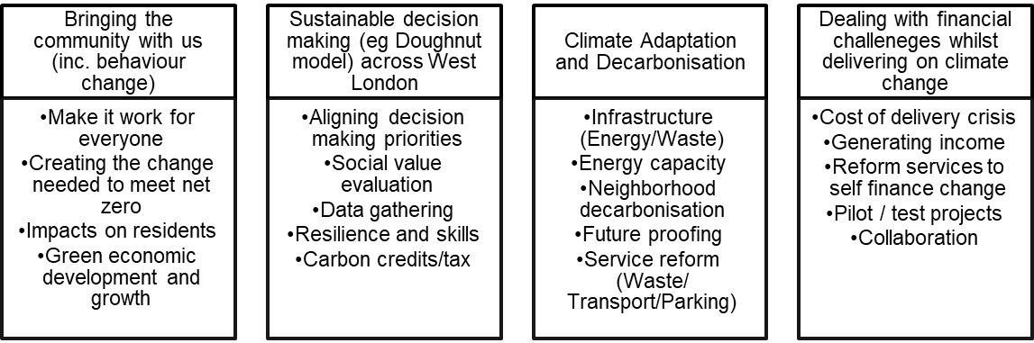
Key areas include behaviour change, data gathering, resilience and skills, social value evaluation and future proofing the system.
- Joint Waste Management Strategy
A key factor in the Joint Waste Management Strategy is the 65% recycling target. To meet this a framework of a joint plan for 2030 to be developed by WLWA and Boroughs was agreed in March 2022. The joint plan must incorporate managing the rising cost of inflation which can only be countered in WLWA by reducing the amount of waste collected.
It is vital in this year that we:
- Increase the proportion of residents using the food waste service and
- Prevent waste at source in the recycling centres.
The agreed framework is shown below:
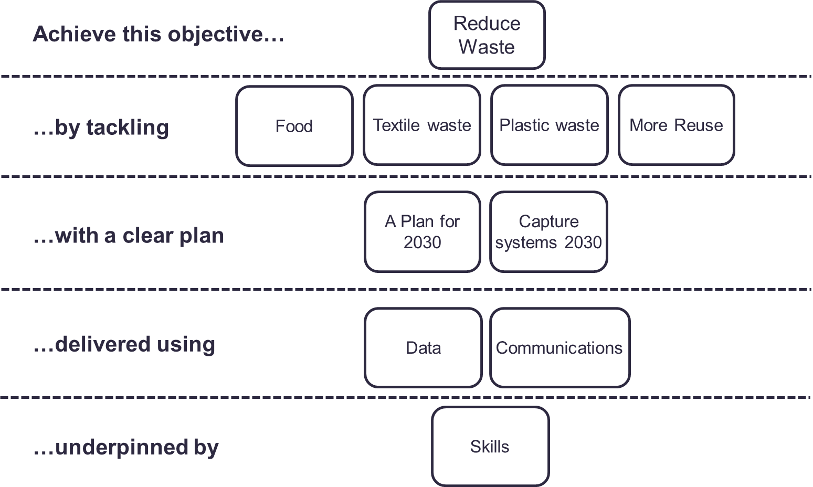
The programme is intrinsically linked to the Authority’s Joint Waste Management Strategy and Business Plan. The projects are driving the design of the new policies and programmes through data, best practice and identification of opportunities, as well as delivering change to meet the desired outcomes and targets in the Strategy and the proposed Budget.

Contact Officers | Peter Tilston, Projects Director 07796 271 713  petertilston@westlondonwaste.gov.uk  Motoko Doolan, Net Zero Carbon Manager 07917 075 876  motokodoolan@westlondonwaste.gov.uk  Sarah Ellis, Strategic Development Lead 07584 631 710  sarahellis@westlondonwaste.gov.uk

Appendix 1 – WLWA average waste composition
